PHX 解锁提取步骤

How to claim your vested PHX

1. 环境（Environment）
- URL:
https://etherscan.io/address/0x741a00905f80adb1334e2b7294e2eb6596aa880e#code

- 浏览器安装 Metamask（或其它钱包插件）, 提取 PHX 的账户可以通过 Metamask（或其它钱包插件）对提取交易签名
Please install Metamask wallet or other wallets. The address should be able to sign the contract through the wallets on Etherscan.

- 国内用户可能需要安装 VPN 软件
VPN is needed for users in Mainland China.

2. 查询（checking PHX balance）
URL:
https://etherscan.io/address/0x741a00905f80adb1334e2b7294e2eb6596aa880e#readProxyContract

查询contract→Read as Proxy界面如下:
Please go to ‘contract→Read as Proxy’:
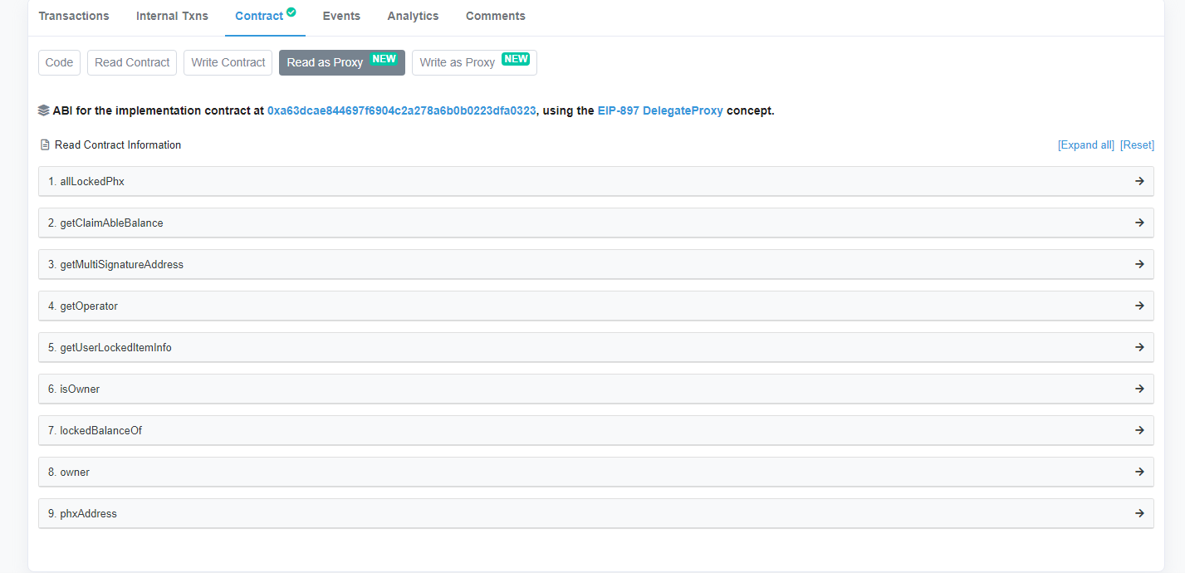

2.1 查询未解锁的PHX数量 (checking locked PHX balance)
进入查询 URL 后，展开函数 lockedBalanceOf，输入自己账户地址，点击 query（查询），下面将显示当前锁定的 PHX 数量。
Go to ‘7. lockedBalanceOf’ and input your address, then press ‘query’. The locked PHX balance will show up.
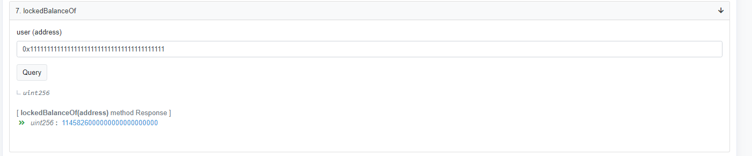

2.2 查询可提取的PHX数量 (checking claimable PHX balance)
进入查询 URL 后，展开函数 getClaimableBalance，输入自己账户地址，点击 query（查询），下面将显示当前可提取的 PHX 数量。
Go to ‘2. getClaimableBalance’ and input your address, then press ‘query’. The claimable PHX balance will show up.

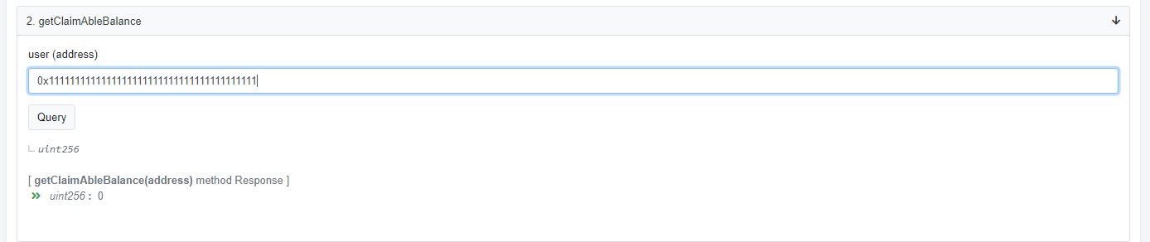

3. 提取PHX (Withdrawing PHX)
URL:
https://etherscan.io/address/0x741a00905f80adb1334e2b7294e2eb6596aa880e#writeProxyContract

界面如下
Please go to ‘contract→Write as Proxy’:
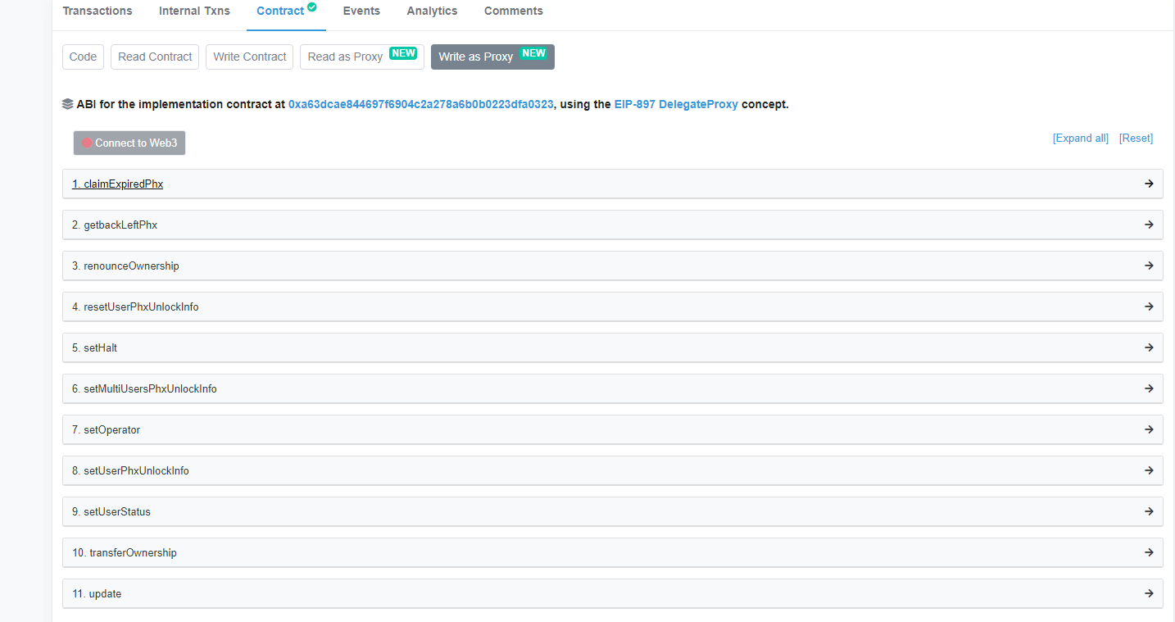
按照下列步骤提取 PHX
- 登录 Metamask （或其它钱包插件）
- 选定自己的账户
- 点击“Connect to Web3”，显示为绿色，表示连接成功
- 展开函数 1.claimExpiredPhx
- 点击 “Write”
- 使用 弹出的 Metamask 签名交易，发送提取交易
Please follow the steps as below:
- Log in your Metamask or other wallets.
- Select your account.
- Press ‘Connect to Web3’. It should appear in green when connected.
- Press ‘1.claimExpiredPhx’.
- Press ‘write’.
- Sign the transaction through your wallet and claim the PHX.

